**USER GUIDE /**

**CONSOLE OPTIONS**

**“IAM-CORE”**

**JAVA PROJECT**

**MSC 2018 FALL**

**Presented by :-   
Thejus and Bhanuja Kaur**

**Step 1** : Refer Documentation to configure the DB first.

**Step 2** : Run the “Main.java” file in the Launcher Package.

**Step 3** : Select whether you want to Login or Signup, enter the corresponding Menu option.

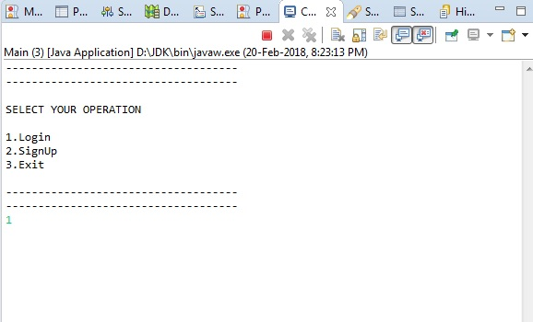

* **Login**-> Enter UID and Password, System then searches and if a matching User profile found, then it moves to the next Step.
* **SignUp**-> Enter UID, email address and passwords all as Strings.

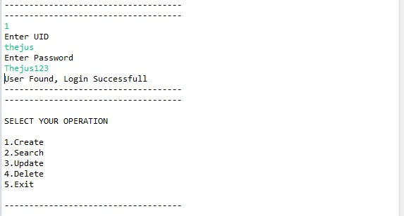

**Step 4** : Main selection menu appears where you can select different CRUD Operations to perform on the DB data.

**Step 5 :** Create Data-> Enter Display name , email and UID.

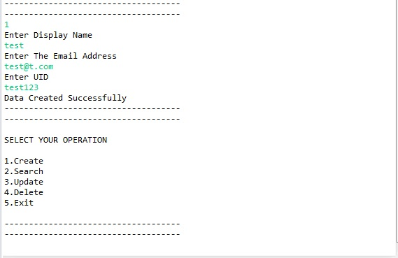

**Step 6** : Search-> Search for the entered data in the DB. It gives a menu to search by name, email or UID. Select respective menu option and then it displays result of the search.

**Step 7** : Update-> Updates the data in the DB. It searches the data by UID and then lets you update name and email, but not UID.

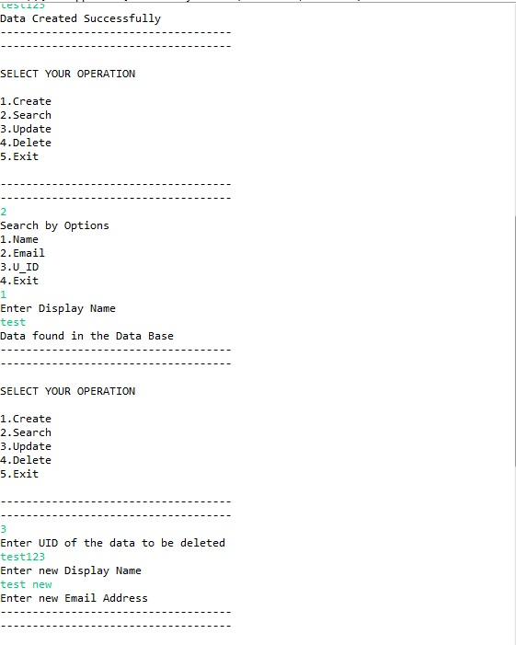

**Step 8** : Delete-> It gives you option to delete Data in the DB by name , email or UID. It then deletes the data from DB.

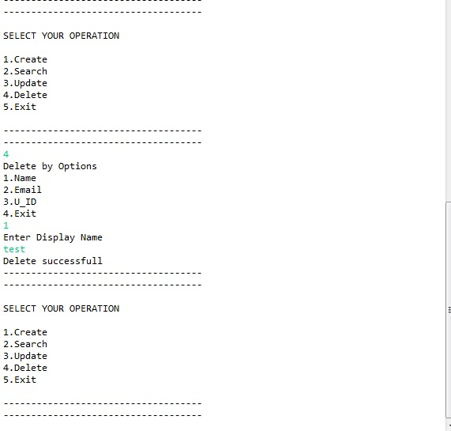

**Step 9** : End of all Operations.